## **Week 4 Homework Submission File: Linux Systems Administration**

### **Step 1: Ensure/Double Check Permissions on Sensitive Files**

1. Permissions on /etc/shadow should allow only root read and write access.  
   * Command to inspect permissions:

* + Command to set permissions (if needed):

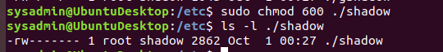

1. Permissions on /etc/gshadow should allow only root read and write access.  
   * Command to inspect permissions:
   * Command to set permissions (if needed):



1. Permissions on /etc/group should allow root read and write access, and allow everyone else read access only.  
   * Command to inspect permissions:
   * Command to set permissions (if needed):



1. Permissions on /etc/passwd should allow root read and write access, and allow everyone else read access only.  
   * Command to inspect permissions:
   * Command to set permissions (if needed):



### **Step 2: Create User Accounts**

1. Add user accounts for sam, joe, amy, sara, and admin.

Sam - n3T!F1!x4@Lur0K&3i$N

Joe - C4l!f0R^N1a@$4nDi3G@

Amy - B0x#sC4^3rA%U$z2L$z

Sara - 9a!Hn4IL$t0Esf3#tN0$e

* + Command to add each user account (include all five users):

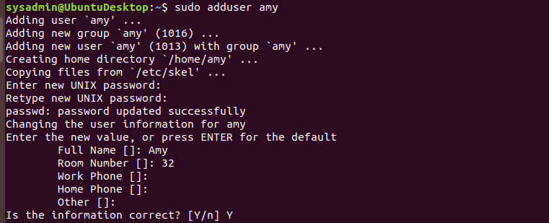

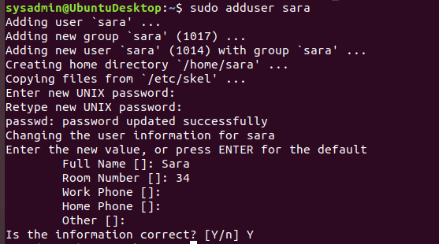

1. Force users to create 16-character passwords incorporating numbers and symbols.  
   * Command to edit pwquality.conf file:

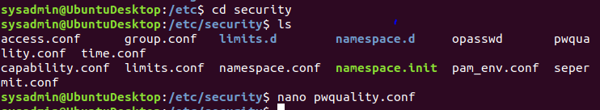

* + Updates to configuration file:

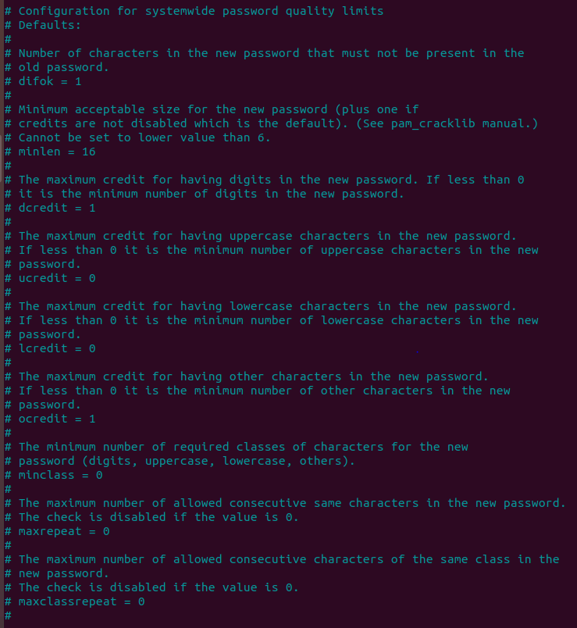

1. Force passwords to expire every 90 days.  
   * Command to to set each new user's password to expire in 90 days (include all five users):

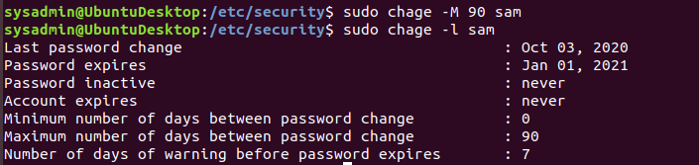



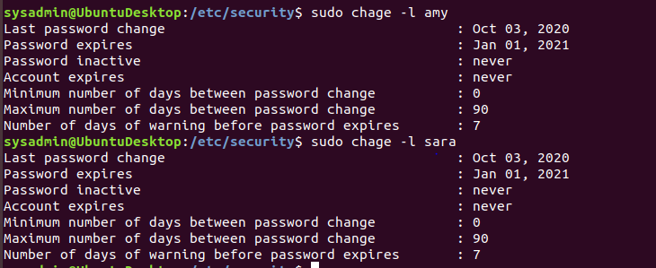

1. Ensure that only the admin has general sudo access.  
   * Command to add admin to the sudo group.

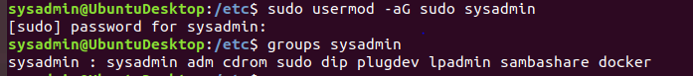

### 

### 

### 

### **Step 3: Create User Group and Collaborative Folder**

1. Add an engineers group to the system.  
   * Command to add group:
   * 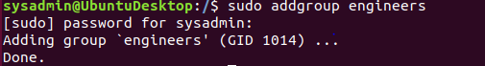
2. Add users sam, joe, amy, and sara to the managed group.  
   * Command to add users to engineers group (include all four users):









1. Create a shared folder for this group at /home/engineers.  
   * Command to create the shared folder:

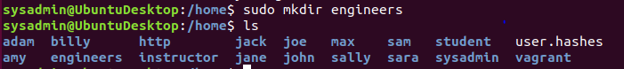

1. Change ownership on the new engineers' shared folder to the engineers group.  
   * Command to change ownership of engineer's shared folder to engineer group:



### 

### **Step 4: Lynis Auditing**

1. Command to install Lynis:



1. Command to see documentation and instructions:



1. Command to run an audit:



1. Provide a report from the Lynis output on what can be done to harden the system.  
   * Screenshot of report output:

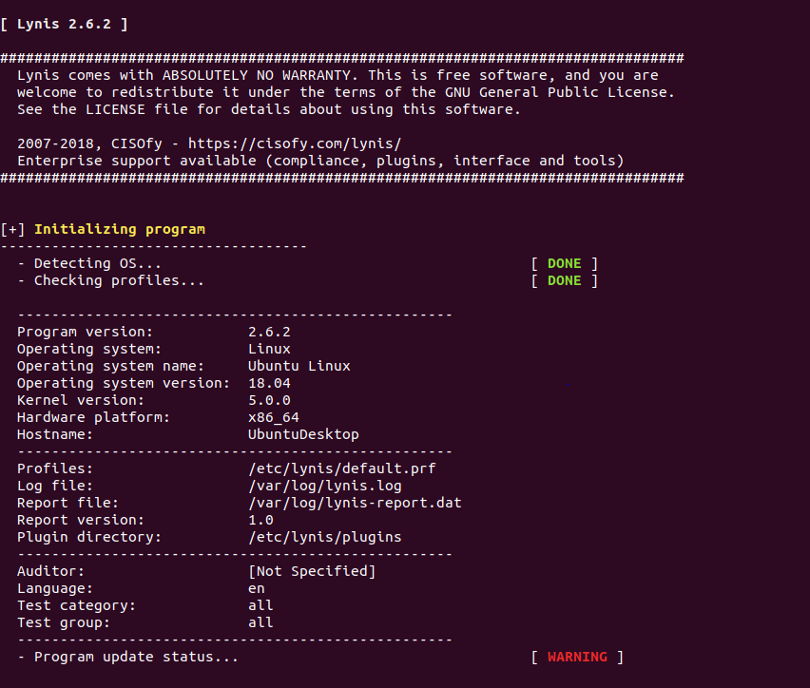

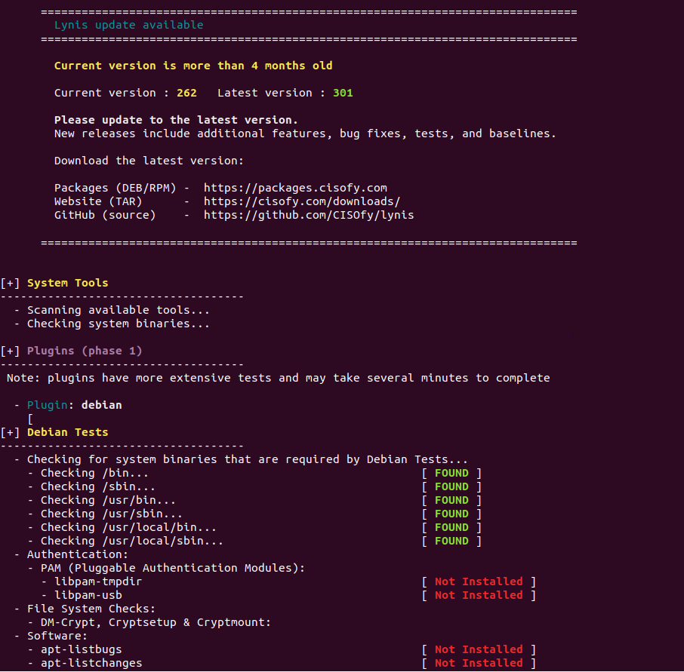

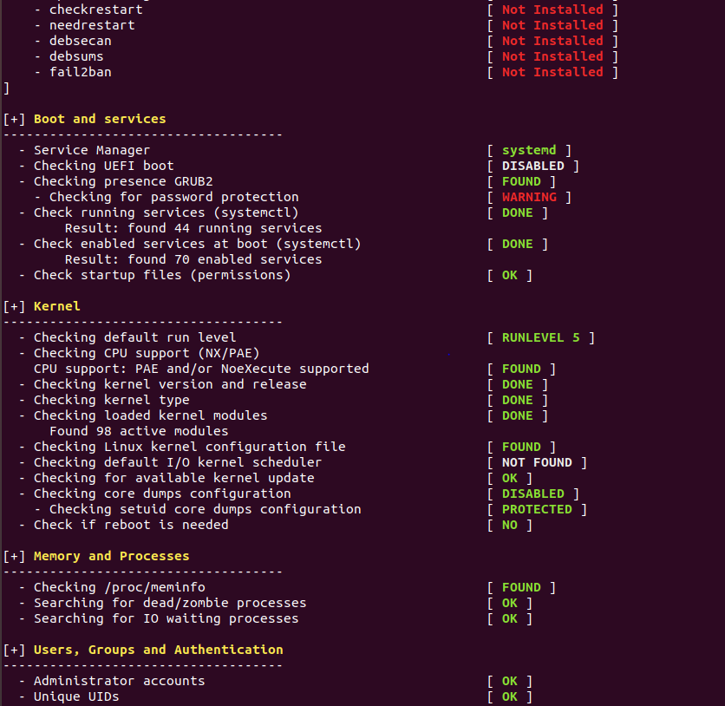

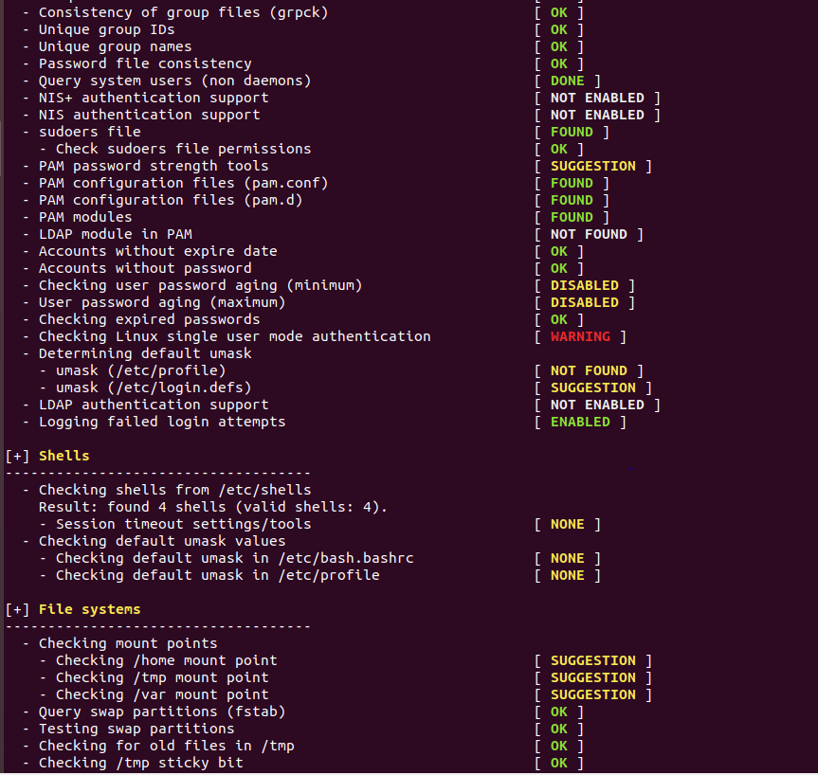

### 

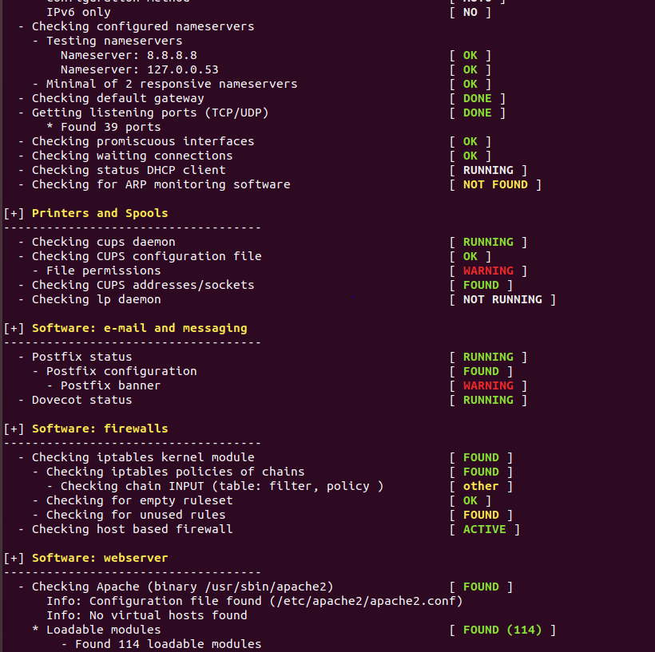

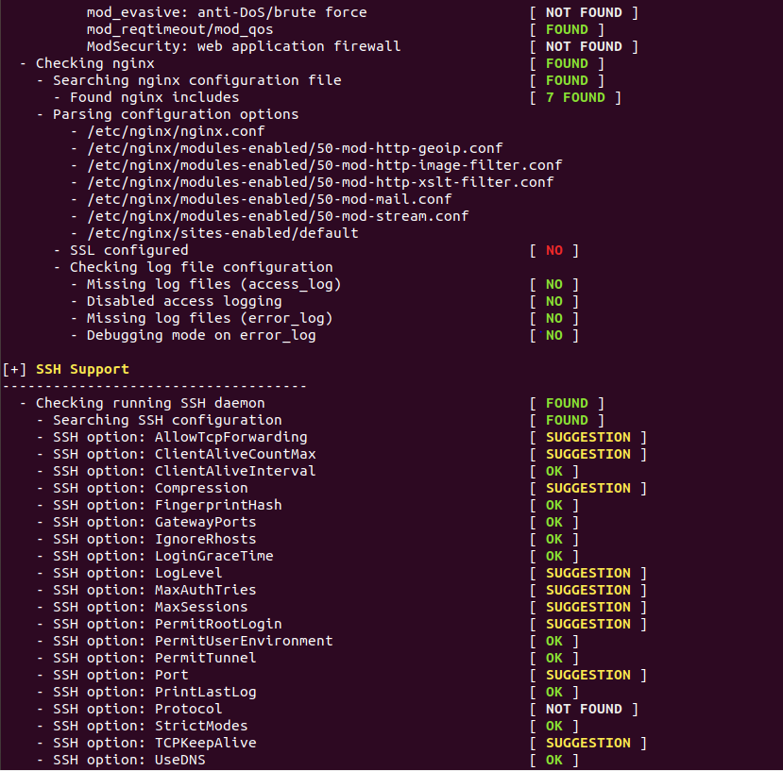

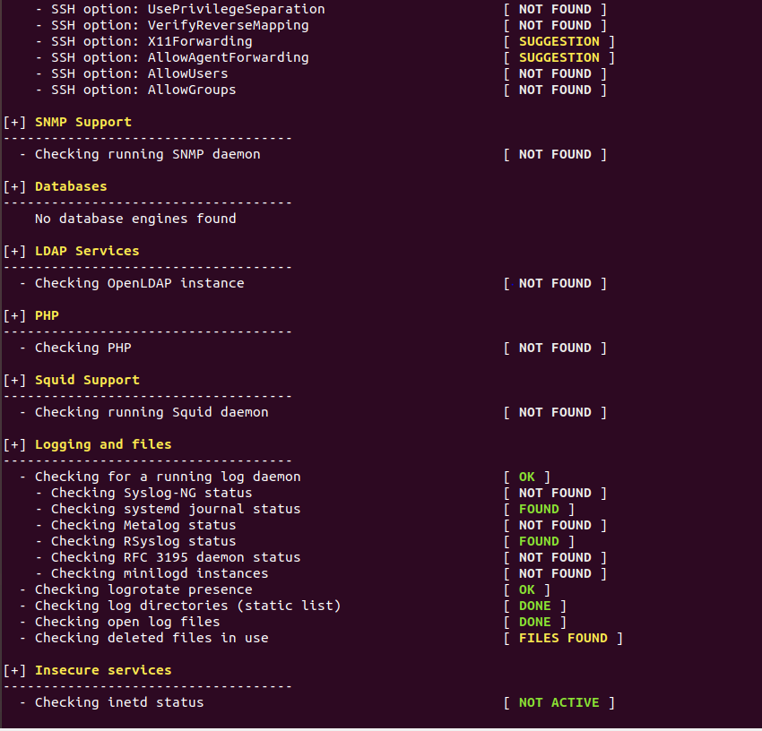

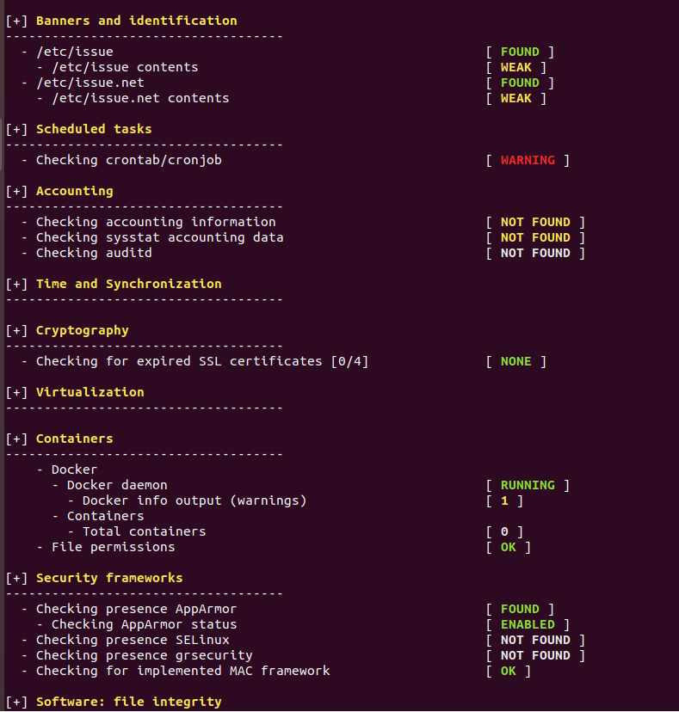

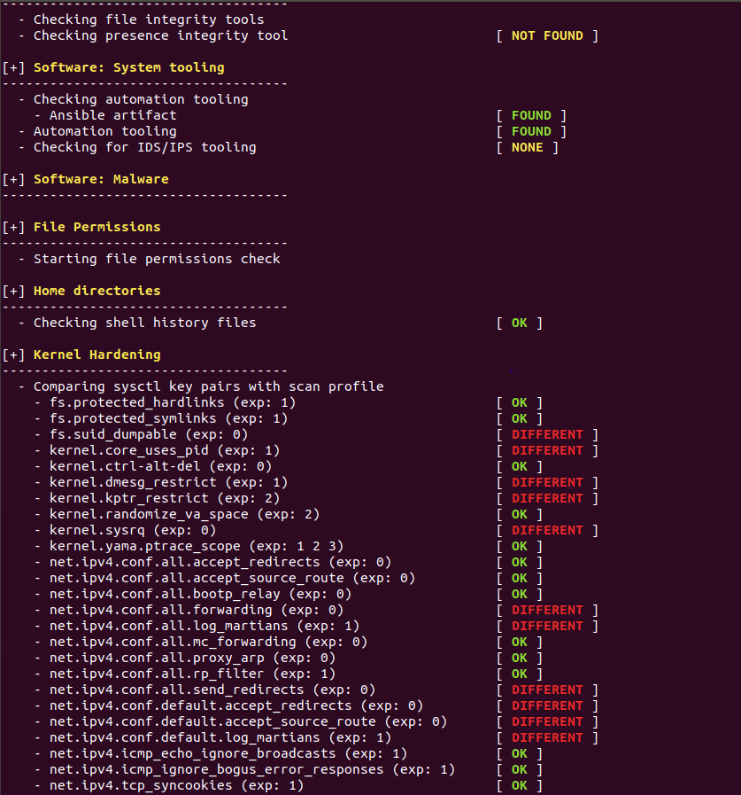

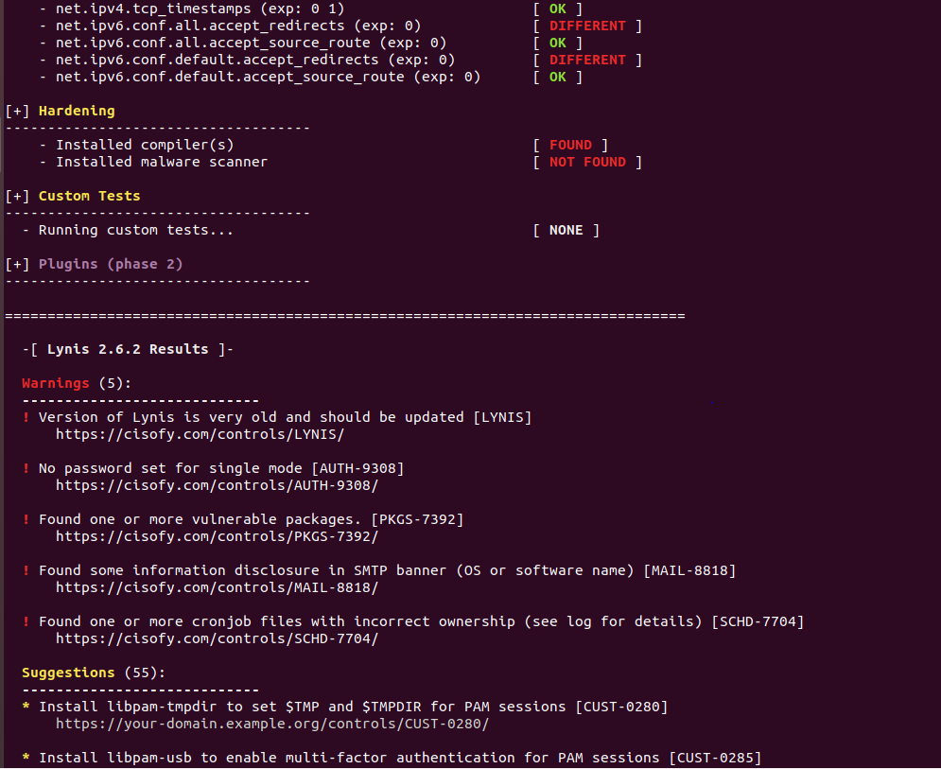

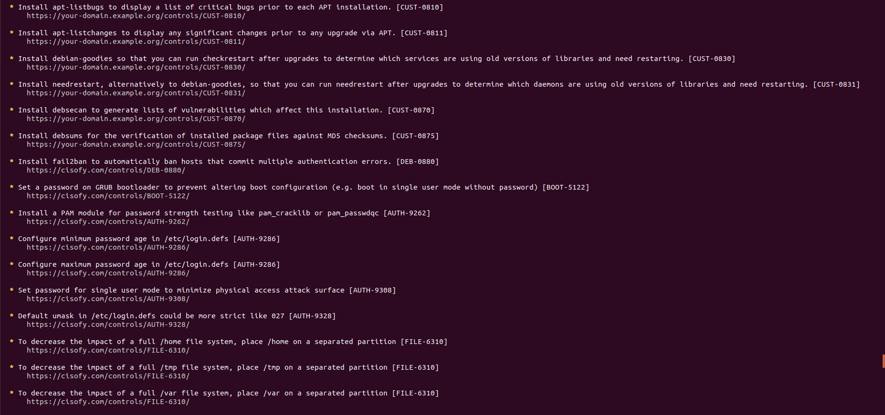

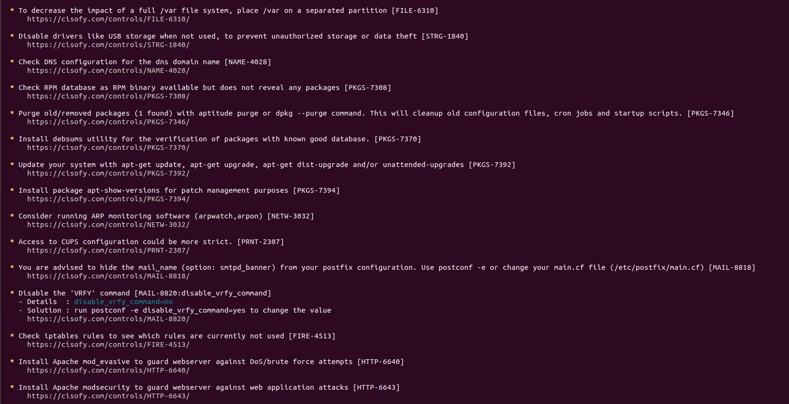

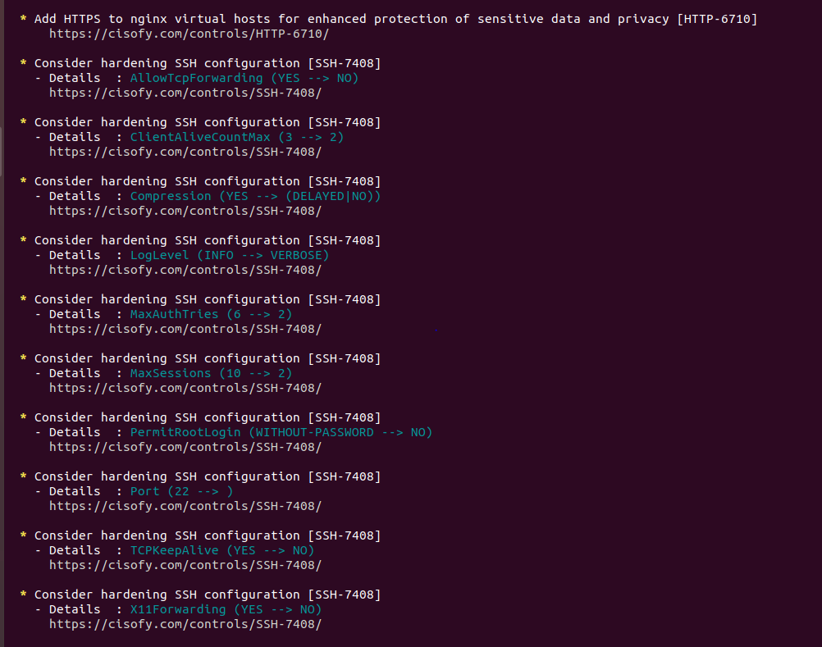

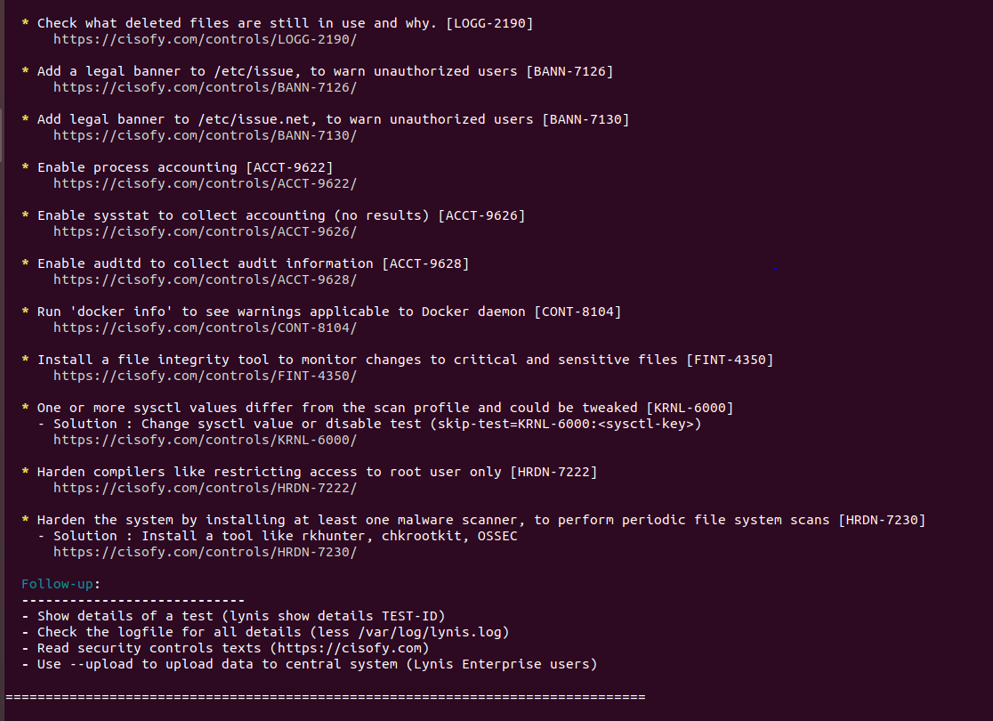

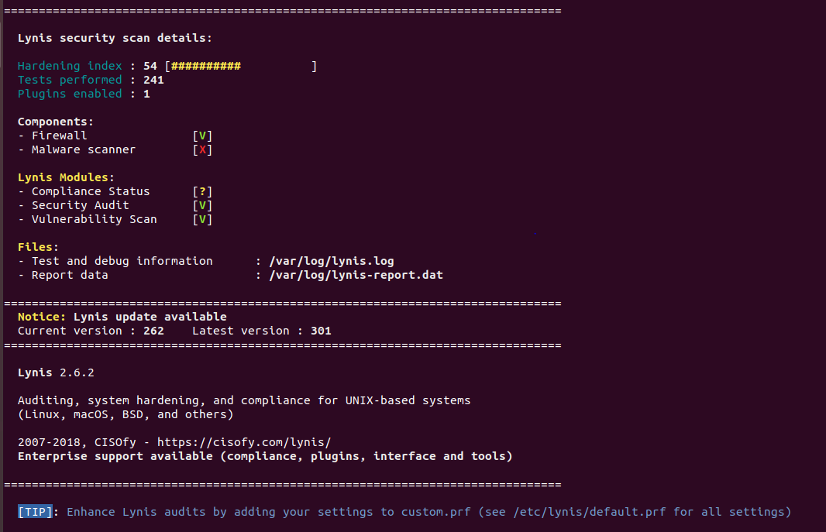

### **Bonus**

1. Command to install chkrootkit:
2. Command to see documentation and instructions:
3. Command to run expert mode:
4. Provide a report from the chrootkit output on what can be done to harden the system.  
   * Screenshot of end of sample output:

© 2020 Trilogy Education Services, a 2U, Inc. brand. All Rights Reserved.